Multiple-choice section

|  |  |  |  |  |  |  |
| --- | --- | --- | --- | --- | --- | --- |
| Question | 1 | 2 | 3 | 4 | 5 | 6 |
| Answer | B | D | A | D | C | B |

Question 1 [8.3]

B

P(x) = -x3 + 3x2 + 7x – 1

P(-2) = -(-2)3 + 3(-2)2 + 7(-2) – 1

= 5

Question 2 [8.2]

D

To transform y = x2 to y = -x2, reflect in the x-axis.

To transform y = -x2 to y = -7x2, dilate by a factor of 7 in the y direction.

To transform y = -7x2 to y = 3 – 7x2, translate 3 units up.

Question 3 [8.3]

A

P(x) = 8 – 3x2 + 5x4

Degree = 4; Leading coefficient = 5; Constant = 8

Question 4 [8.3]

D

P(x) = x3 – x2 + 3x – 2

P(1) = 13 – 12 + 3 × 1 – 2

= 1 – 1 + 3 – 2

= 1

Question 5 [8.5]

C

y = 5x3 – 2x − 6 + 11x2

For x = 0: y = -6

Question 6 [8.2]

B

y = x3

Dilating by a factor of 4: y = 4x3

Translating the graph 2 units to the right: y = 4(x – 2)3

Translating the graph 3 units down: y = 4(x – 2)3 – 3

Multiple-choice total marks: 6

Short answer section

Question 7 3 marks [8.1, 8.3]

(a) A polynomial with an equation y = x3 + 2x2 – 7 is a cubic equation.

(b) The equation y = 3x2 – 4x + 1 is a non-monic quadratic equation.

(c) In a polynomial, the term with the highest power is called the leading term.

Question 8 2 marks [8.2]

When a polynomial is translated, the graph is moved right or left and/or up or down without the shape being changed.

Question 9 4 marks [8.2]

(a), (c)

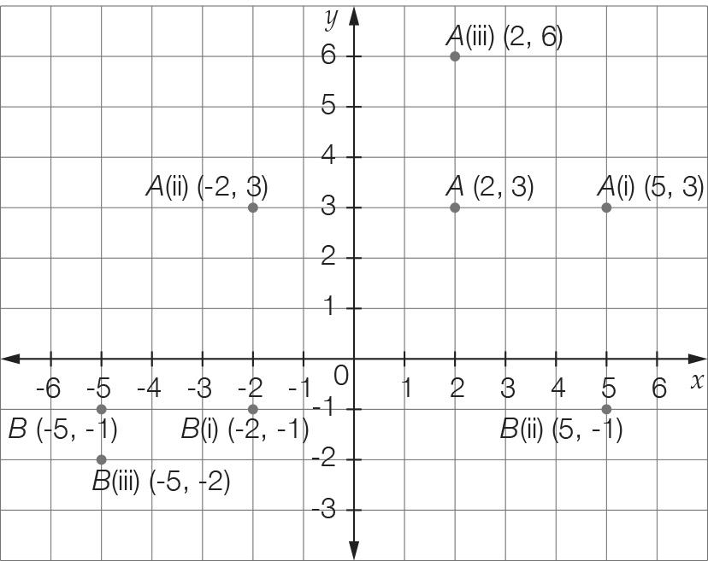

(b) A (i) (5, 3) (ii) (-2, 3) (iii) (2, 6)

B (i) (-2, -1) (ii) (5, -1) (iii) (-5, -2)

Question 10 8 marks [8.2]

(a), (c)

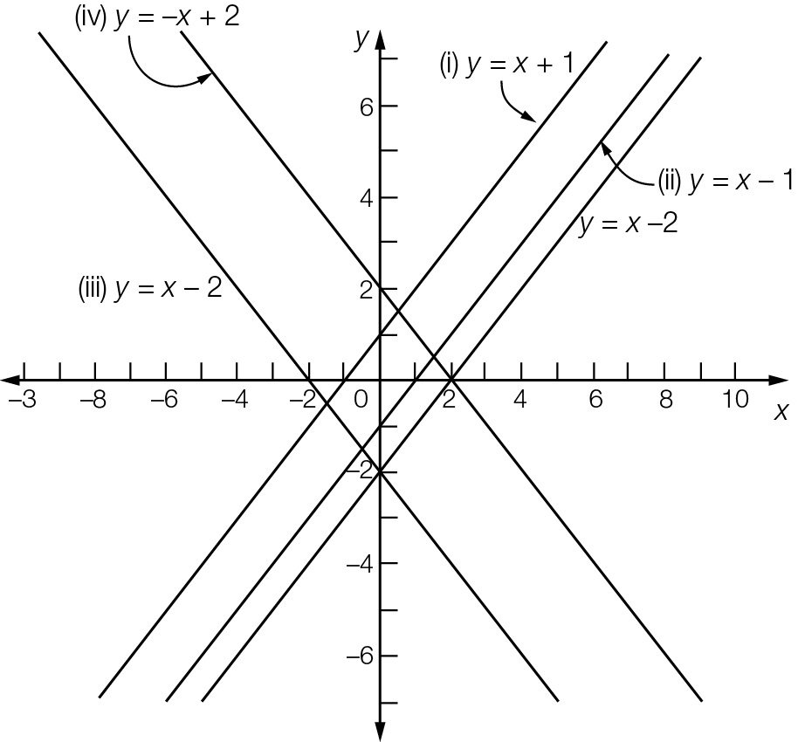

(b) (i) y = x + 1 (ii) y = x – 1 (iii) y = -x – 2 (iv) y = -x + 2

Question 11 8 marks [8.2]

(a) (i) (0, 8) (ii) (3, -1) (iii) (2, 0) and (4, 0)

(b), (c)

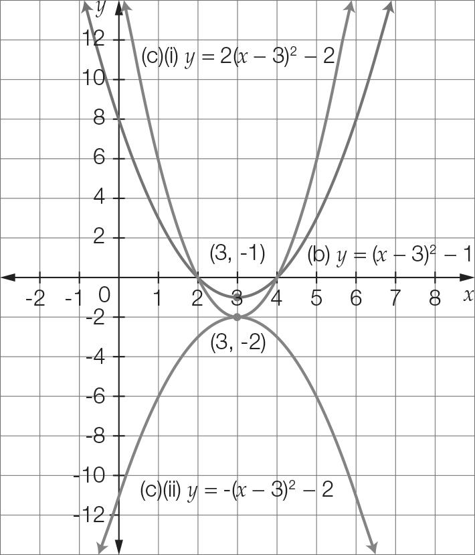

(c) (i) y = 2(x – 3)2 – 2 (ii) y = -(x – 3)2 – 1

Question 12 3 marks [8.2]

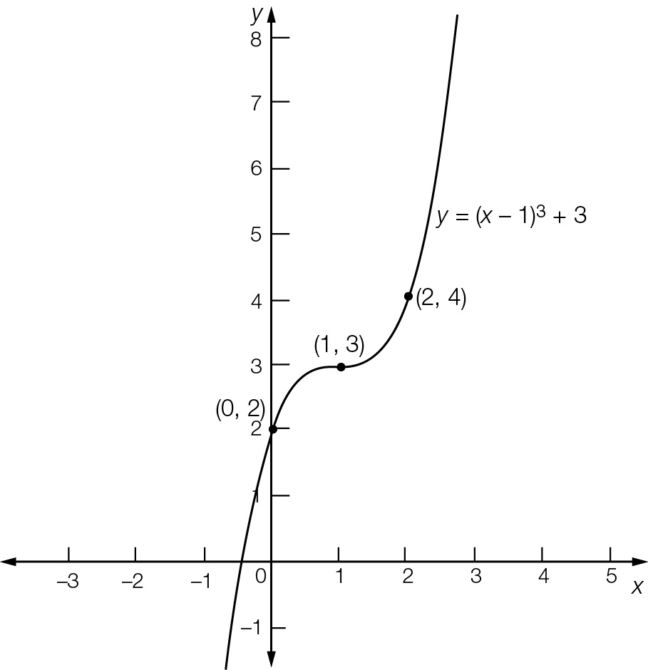

Point of inflection = (1, 3)  
y-intercept = (0, 2)  
Required point = (2, 4)

Question 13 4 marks [8.2]

(a) y = x2  
Translate 4 to the left: y = (x + 4)2   
Translate 4 to the left and 3 down: y = (x + 4)2 – 3

(b) y = x2  
Reflect in the x-axis: y = -x2  
Reflect in the x-axis, dilate by 2 in the x-direction: y = -2x2  
Reflect in the x-axis, dilate by 2 in the y-direction, translate 1 to the right: y = -2(x – 1)2  
Reflect in the x-axis, dilate by 2 in the y-direction, translate 1 to the right, translate 5 up  
y = -2(x − 1)2 + 5

Question 14 4 marks [8.5]

For x = 0, y = c  
c = 12

For x = 1, a + b + 12 = 0 [1]

For x = -4, 16a – 4b + 12 = 0 [2]

Add equations 4 × [1] and [2]

20a = -60

a = -3

By substitution in equation [1]

-3 + b + 12 = 0

b = -9

a = -3, b = -9, c = 12

Question 15 2 marks [8.4]

P(x) = 4x2 + x – 3

P(-1) = 4 ×  – 1 – 3

= 0

Given that P(-1) = 0, then x + 1 is a factor.

Question 16 2 marks [8.3]

Answers will vary, but the polynomial must have four terms, the highest power of x must be 5 and the coefficient of this term must be a negative. e.g. -2x5 + 3x2 + 5x – 2

Question 17 4 marks [8.3, 8.4]

(a) P(1) = 1 – 2 – 1 + 2

= 0

So x – 1 is a factor.

x2 − x – 2

x – 1 ) x3 – 2x2 − x + 2

-(x3 – x2)

-x2 − x

-(-x2 + x)

-2x + 2

-(-2x + 2)

0

x3 – 2x2 − x + 2 = (x – 1)(x2 – x – 2)

= (x – 1)(x + 1)(x – 2)

(b) x3 – 2x2 − x + 2

= (x – 1)(x + 1)(x – 2)

= 0  
So x = 1, x = -1 or x = 2.

Question 18 4 marks [8.3]

2a(x) × b(x) − c(x)

= 2(2x – 3)(5 – 2x2) − (3x3 + 5x – 4)

= 20x − 8x3 – 30 + 12x2 − 3x3 − 5x + 4

= -11x3 + 12x2 + 15x – 26

Question 19 2 marks [8.3]

Answers will vary, but polynomial must be a cubic and P(1) must be zero.

Question 20 2 marks [8.3]

x2 – kx + 6

Substitute x = 2:

P(2) = (2)2 – 2k + 6 = 0

2k = 10  
k = 5

Short answer total marks: 52

Extended answer section

Question 21 5 marks [8.2]

(a) y = 4 – 0.25(x – 4)2 + 4  
= 8 – 0.25(x – 4)2

(b) 8 – 0.25(x – 4)2 = 0  
32 – (x – 4)2 = 0  
(+ (x – 4)) ( − (x – 4)) = 0  
x = 4 –   
x = 9.7 m (reject negative value for x)

(c) Maximum height at vertex (4, 8) is 8 m.

Question 22 6 marks [8.5]

(a) y = 0.01(x3 – 23x2 + 60x)  
= 0.01x(x2 – 23x + 60)   
= 0.01x(x – 3)(x – 20)

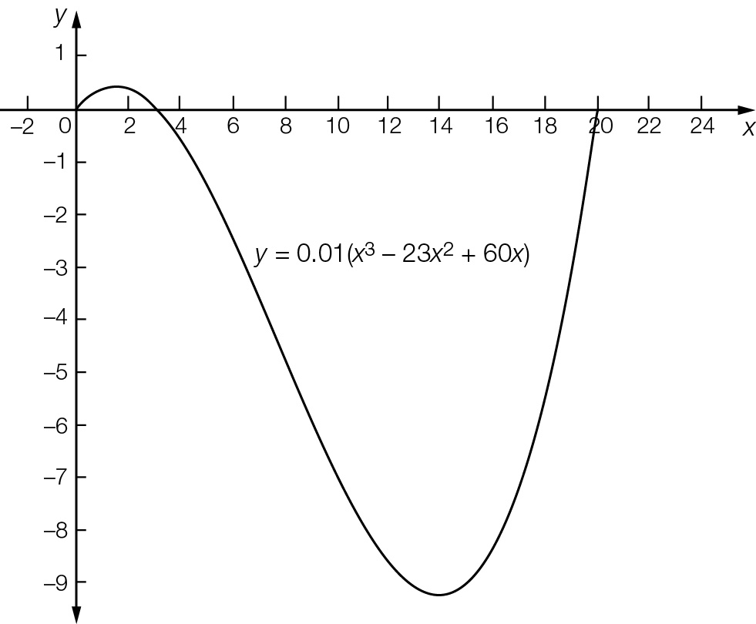

(b)x = 0, 3, 20 (where y = 0)

(c) Distance from one side to the other  
= 20 – 0  
= 20 m

Question 23 5 marks [8.5]

(a) Graph shown where d is on the y-axis and w is on the x-axis.

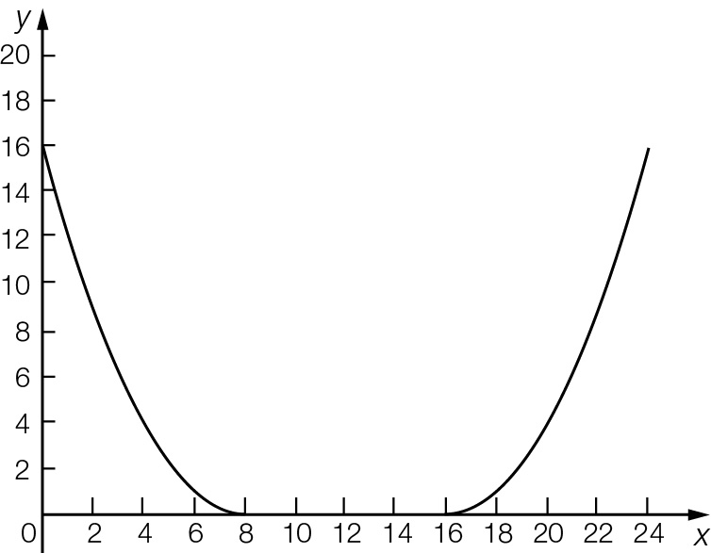

(b) 24 cm

(c) Depth of bowl (where x = 0)  
= (-8)2  
= 16 cm

Extended answer total marks: 16

TOTAL test marks: 74